
Quick and Fun Phonics Games
*Play ‘I Spy’, using letter sounds (not names). E.g. ‘I spy something beginning with mmm.’ This is great for helping children to distinguish the initial sound in words and link this with different objects.
**If your child is really good at ‘I Spy’, you could challenge them by giving them the final sound in the word instead. E.g. ‘I spy something ending with lll. (e.g. ball)


*Play the ‘Robot Game’. Break down simple words so that you are saying each individual sound. E.g. ‘c-a-t’ or ‘sh-i-p’. Ask your child to ‘squash’ the sounds together and tell you what the word is. This develops blending skills, which we use for reading.
**Alternatively, you can reverse the ‘Robot Game’. Tell your child the full word (e.g. ‘mud’, ‘pop’, ‘lip’) and ask to break up the sounds (so it becomes ‘m-u-d’. ‘p-o-p’, ‘l-i-p’). This develops segmenting skills, which we use for spelling.

*When you are in the supermarket, give your child the first sound of an item on your shopping list and get them to guess what you are buying. E.g. ‘ssss’ which could be sausages, spaghetti, soup, satsuma etc.

*Pick a letter and challenge yourselves to see how many different places you can spot it (e.g. within 5 minutes). It could be on food packaging, road signs, book covers etc.

*Visit http://www.phonicsplay.co.uk/ for more fun games:
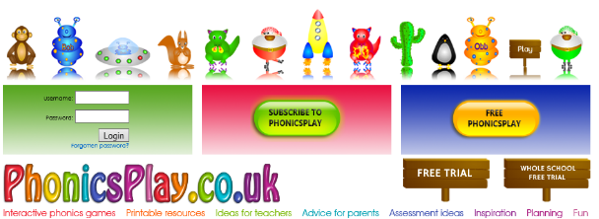
You can access some free games without log-in details. Select ‘Free Phonics Play’, then select ‘Children’ and you will find a selection of games you can play together. (Have a look at the games available within ‘Phase 2’ because this is where most children are working at the moment.) The children have been playing ‘Pick a Picture’ at school recently.

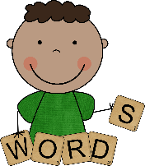
*Don’t forget, we send home sets of letters each week that your child will be focussing on in their phonics sessions. You can try and make some words together, by moving the letters around. Don’t worry if they aren’t ‘real’ words (e.g. ‘pag’ or ‘sim’) because your child will still be using the same skills to blend to read them!

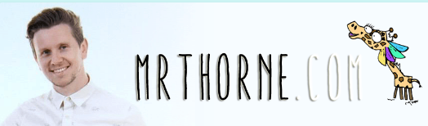
*Visit http://mrthorne.com/ (Mr Thorne Does Phonics) where you will find some really lovely videos featuring Geraldine the Giraffe, which you can watch with your child.

